**Week 1**

**Syllabus**

# Professional Certificate Career Support

## Coursera Community and Career Support

As a Data Science learner on Coursera, you have access to networking opportunities in Coursera’s [Professional Certificate Community](http://bit.ly/2Ij0Kg9) and [Data Science](http://bit.ly/2VEY9VI) forums. Talk about what you’re learning, ask questions, find peers to work with on projects, and share your career goals.

## Post-Completion Career Support Services for Professional Certificates

Completing a Professional Certificate on Coursera unlocks access to a private Professional Certificate Alumni Resources community, which provides exclusive career support resources, including:

* Step-by-step **guide to ensure your success** at every stage of your job search.
* 1 year of **free access** to Big Interview’s expert video lessons, resume builder, and interactive interview practice tools (a $79/month value).
* **A network** and support of fellow completers of Coursera Professional Certificates.
* A variety of **special offers** such as career coaching, webinars, and more.

After completing your Professional Certificate, you’ll get an email telling you how to access these career support resources.

Questions? You can also always contact Coursera Careers Team by emailing [career-support@coursera.org](mailto:professional-certificate-career-support@coursera.org).

**Defining Data Science**

Data science is the field of exploring, manipulating, and analyzing data, and using data to answer questions or make recommendations. Data science involves using data to answer questions or make recommendations.

* Data Science is a process, not an event. It is the process of using data to understand different things, to understand the world.
* For me is when you have a model or hypothesis of a problem, and you try to validate that hypothesis or model with your data.
* Data science is the art of uncovering the insights and trends that are hiding behind data. It's when you translate data into a story. So use storytelling to generate insight. And with these insights, you can make strategic choices for a company or an institution.
* Data science is a field about processes and systems to extract data from various forms of whether it is unstructured or structured form.
* Data science is the study of data. Like biological sciences is a study of biology, physical sciences, it's the study of physical reactions. Data is real, data has real properties, and we need to study them if we're going to work on them.
* Data Science involves data and some science. The definition or the name came up in the 80s and 90s when some professors were looking into the statistics curriculum, and they thought it would be better to call it data science. But what is Data Science? I'd see data science as one's attempt to work with data, to find answers to questions that they are exploring. In a nutshell, it's more about data than it is about science. If you have data, and you have curiosity, and you're working with data, and you're manipulating it, you're exploring it, the very exercise of going through analyzing data, trying to get some answers from it is data science. Data science is relevant today because we have tons of data available. We used to worry about lack of data. Now we have a data deluge. In the past, we didn't have algorithms, now we have algorithms. In the past, the software was expensive, now it's open source and free. In the past, we couldn't store large amounts of data, now for a fraction of the cost, we can have gazillions of datasets for a very low cost. So, the tools to work with data, the very availability of data, and the ability to store and analyze data, it's all cheap, it's all available, it's all ubiquitous, it's here. There's never been a better time to be a data scientist.

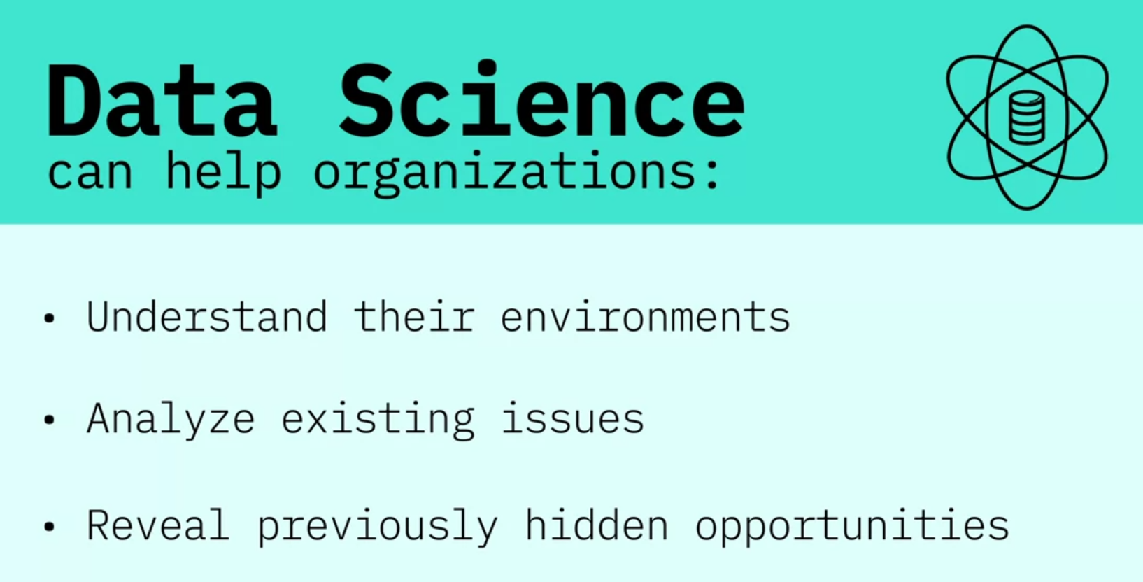

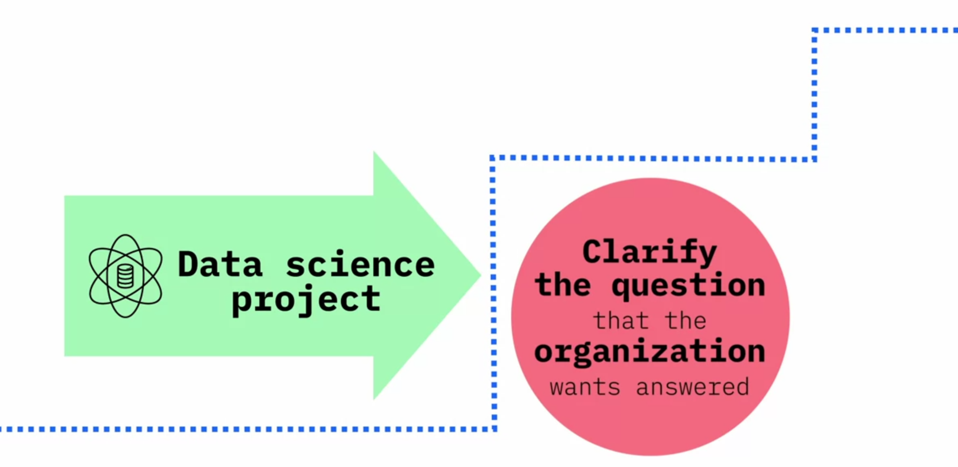

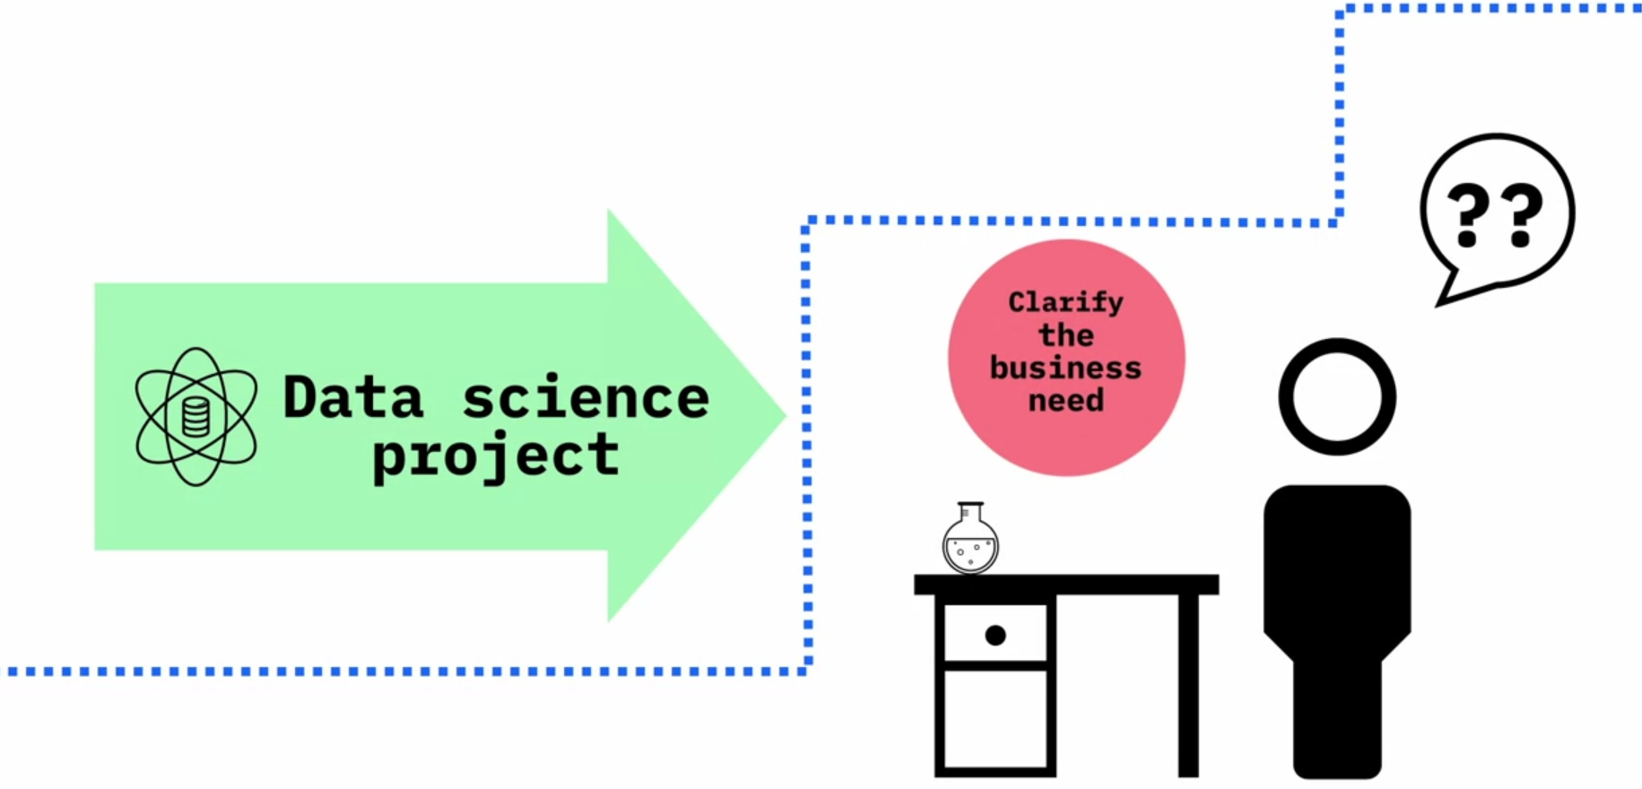

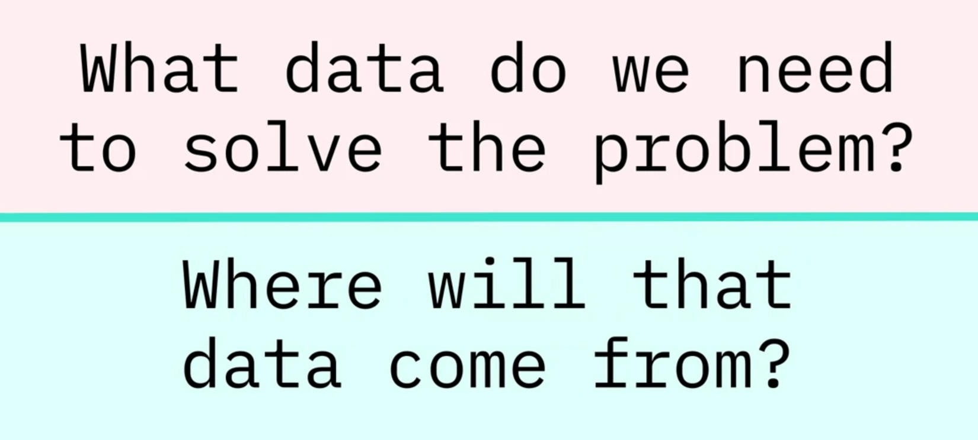

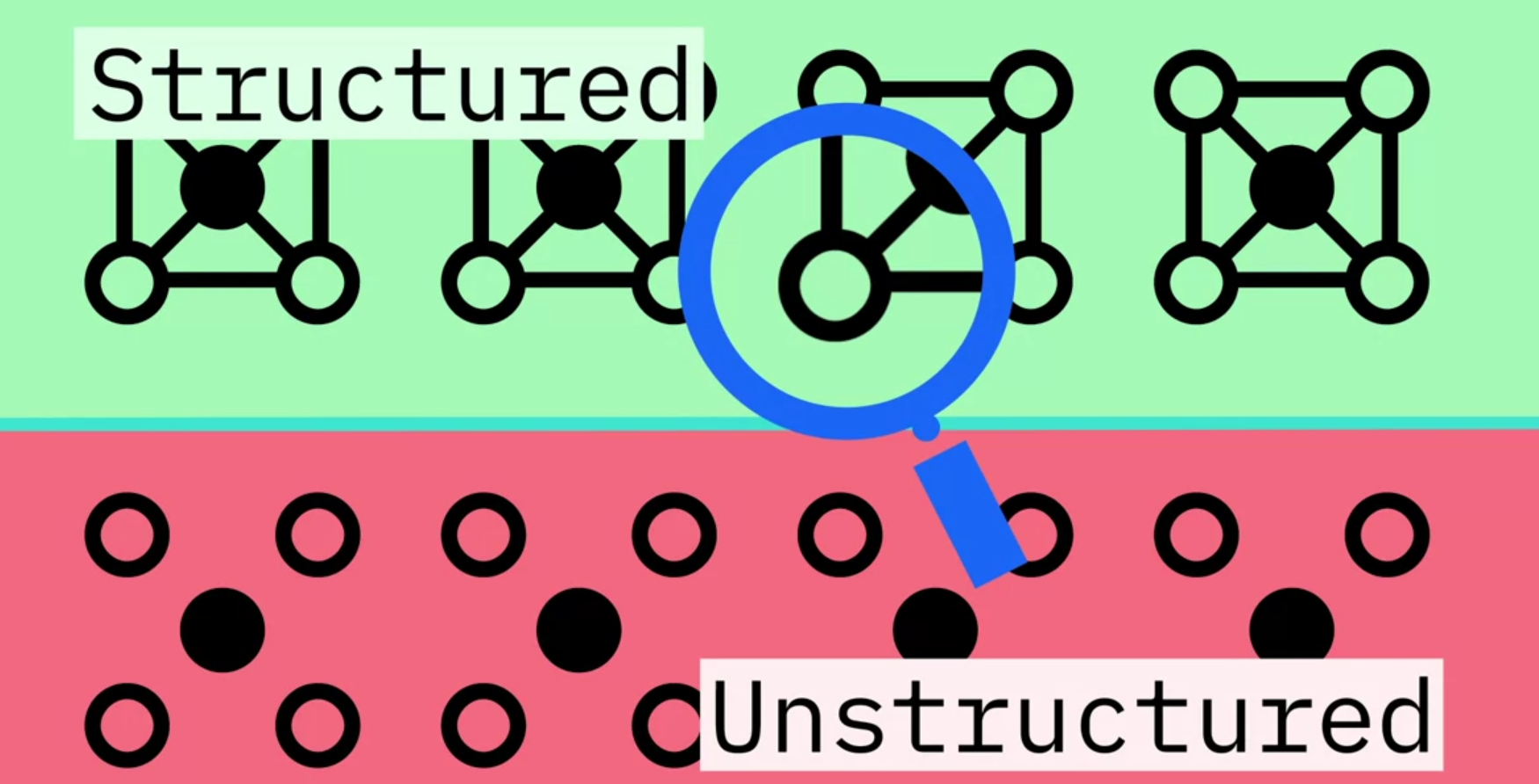

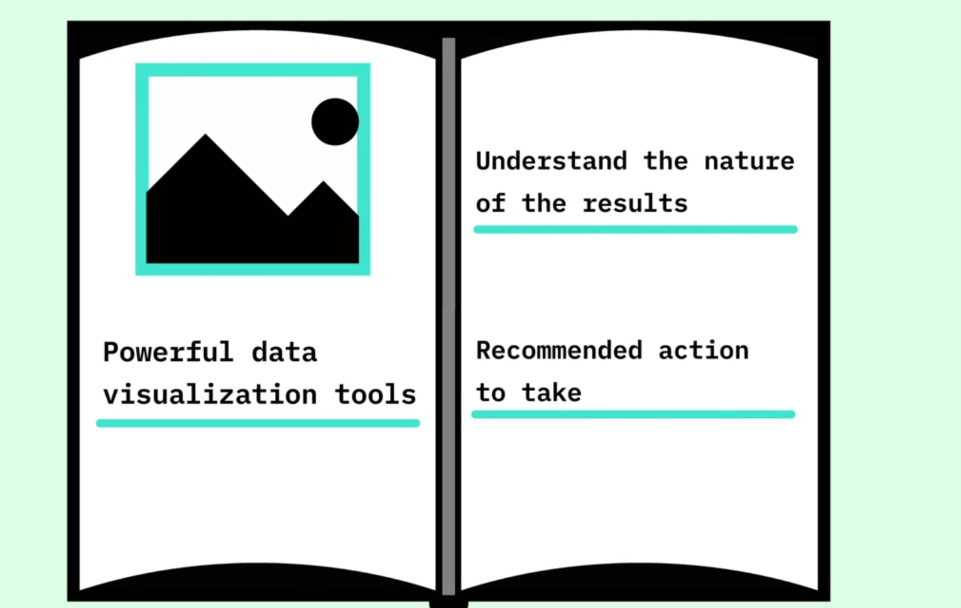

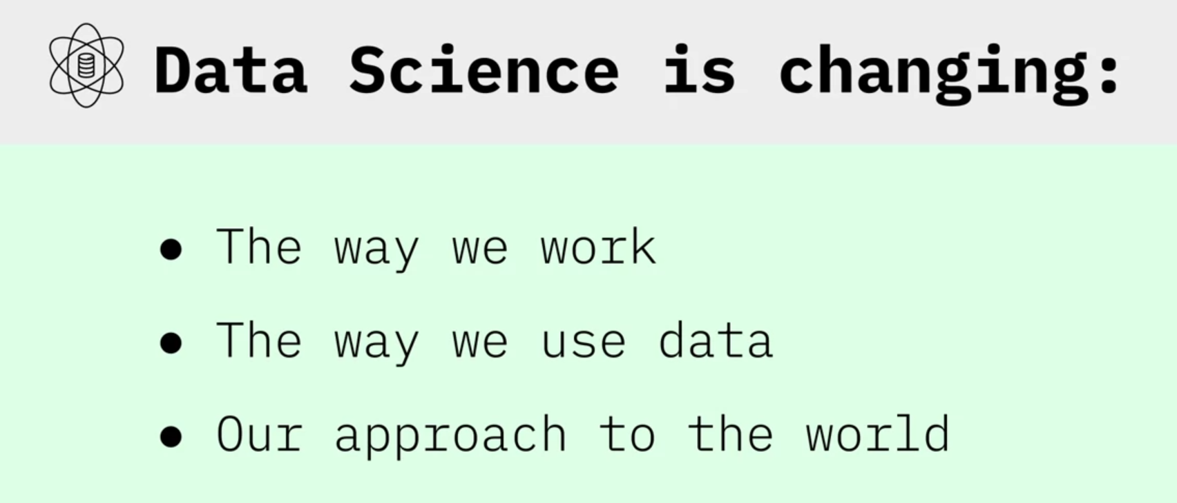

My advice to an aspiring data scientist is to be curious, extremely argumentative and judgmental. Curiosity is absolute must. If you're not curious, you would not know what to do with the data. Judgmental because if you do not have preconceived notions about things you wouldn't know where to begin with. Argumentative because if you can argument and if you can plead a case, at least you can start somewhere and then you learn from data and then you modify your assumptions and hypotheses and your data would help you learn. And you may start at the wrong point. You may say that I thought I believed this, but now with data I know this. So, this allows you a learning process. So, curiosity being able to take a position, strong position, and then moving forward with it. The other thing that the data scientist [should] would need is some comfort and flexibility with analytics platforms: some software, some computing platform, but that's secondary. The most important thing is curiosity and the ability to take positions. Once you have done that, once you've analyzed, then you've got some answers. And that's the last thing that a data scientist need, and that is the ability to tell a story. That once you have your analytics, once you have your tabulations, now you should be able to tell a great story from it. Because if you don't tell a great story from it, your findings will remain hidden, remain buried, nobody would know. Your rise to prominence is pretty much relying on your ability to tell great stories. A starting point would be to see what is your competitive advantage. Do you want to be a data scientist in any field or a specific field? Because, let's say you want to be a data scientist and work for an IT firm or a web-based or Internet based firm, then you need a different set of skills. And if you want to be a data scientist, for lets say, in the health industry, then you need different sets of skills. So figure out first what you're interested, and what is your competitive advantage. Your competitive advantage is not necessarily going to be your analytical skills. Your competitive advantage is your understanding of some aspect of life where you exceed beyond others in understanding that. Maybe it's film, maybe it's retail, maybe it's health, maybe it's computers. Once you've figured out where your expertise lies, then you start acquiring analytical skills. What platforms to learn and those platforms, those tools would be specific to the industry that you're interested in. And then once you have got some proficiency in the tools, the next thing would be to apply your skills to real problems, and then tell the rest of the world what you can do with it.

**Course Text Book: ‘Getting Started with Data Science’ Publisher: IBM Press; 1 edition (Dec 13 2015) Print.**

**Author: Murtaza Haider**

**Prescribed Reading: Chapter 1 Pg. 4**

**Data Science: The Sexiest Job in the 21st Century**

In the data-driven world, data scientists have emerged as a hot commodity. The chase is on to find the best talent in data science. Already, experts estimate that millions of jobs in data science might remain vacant for the lack of readily available talent. The global search for skilled data scientists is not merely a search for statisticians or computer scientists. In fact, the firms are searching for well-rounded individuals who possess the subject matter expertise, some experience in software programming and analytics, and exceptional communication skills.

Our digital footprint has expanded rapidly over the past 10 years. The size of the digital universe was roughly 130 billion gigabytes in 1995. By 2020, this number will swell to 40 trillion gigabytes. Companies will compete for hundreds of thousands, if not millions, of new workers needed to navigate the digital world. No wonder the prestigious Harvard Business Review called data science the sexiest job in the 21st century.

A report by the McKinsey Global Institute warns of huge talent shortages for data and analytics. By 2018, the United States alone could face a shortage of 140,000 to 190,000 people with deep analytical skills as well as 1.5 million managers and analysts with the know-how to use the analysis of big data to make effective decisions.

Because the digital revolution has touched every aspect of our lives, the opportunity to benefit from learning about our behaviors is more so now than ever before. Given the right data, marketers can take sneak peeks into our habit formation. Research in neurology and psychology is revealing how habits and preferences are formed and retailers like Target are out to profit from it. However, the retailers can only do so if they have data scientists working for them. “For this reason, it is like an arms race to hire statisticians nowadays”, said Andreas Weigend, the former chief scientist at Amazon.com.

There is still the need to convince the C-suite executives of the benefits of data and analytics. It appears that the senior management might be a step or two behind the middle management in being informed of the potential of analytics-driven planning. Professor Peter Fader, who manages the Customer Analytics Initiative at Wharton, knows that executives reach the C-suite without having to interact with data. He believes that the real change will happen when executives are well-versed in data and analytics.

SAP, a leader in data and analytics, reported from a survey that 92% of the responding firms in its sample experienced a significant increase in their data holdings. At the same time, three-quarters identified the need for new data science skills in their firms. Accenture believes that the demand for data scientists may outstrip supply by 250,000 in 2015 alone. A similar survey of 150 executives by KPMG in 2014 found that 85% of the respondents did not know how to analyze data. Most organizations are unable to connect the dots because they do not fully understand how data and analytics can transform their business, Alwin Magimay, head of digital and analytics for KPMG UK, said in an interview in May 2015.

Bernard Marr writing for Forbes also raises concerns about the insufficient analytics talent. There just aren’t enough people with the required skills to analyze and interpret this information-transforming it from raw numerical (or other) data into actionable insights-the ultimate aim of any Big Data-driven initiative, he wrote. Bernard quotes a survey by Gartner of business leaders of whom more than 50% reported the lack of in-house expertise in data science.

Bernard reported on Walmart, which turned to crowd-sourcing for its analytics need. Walmart approached Kaggle to host a competition for analyzing its proprietary data. The retailer provided sales data from a shortlist of stores and asked the competitors to develop better forecasts of sales based on promotion schemes.

Given the shortage of data scientists, employers are willing to pay top dollars for the talent. Michael Chui, a principal at McKinsey, knows this too well. “Data science has become relevant to every company … There’s a war for this type of talent,” he said in an interview. Take Paul Minton, for example. He was making $20,000 serving tables at a restaurant. He had majored in math at college. Mr. Minton took a three-month programming course that changed everything. He made over $100,000 in 2014 as a data scientist for a web startup in San Francisco. Six figures, right off the bat … To me, it was astonishing, said Mr Minton.

Could Mr Minton be exceptionally fortunate, or are such high salaries the norm? Luck had little to do with it; the New York Times reported $100,000 as the average base salary of a software engineer and $112,000 for data scientists.

Lesson summary:

* Data science is the study of large quantities of data, which can reveal insights that help organizations make strategic choices.
* There are  many paths to a career in data science; most, but not all, involve a little math, a little science, and a lot of curiosity about data.
* New data scientists need to be curious, judgemental and argumentative.
* Why data science is considered the sexiest job in the 21st century, paying high salaries for skilled workers.

**What Do Data Scientists Do?**

Using complicated machine learning algorithms does not always guarantee achieving a better performance. Occasionally, a simple algorithm such as k-nearest neighbor can yield a satisfactory performance comparable to the one achieved using a complicated algorithm. It all depends on the data.

Let me explain regression in the simplest possible terms. If you have ever taken a cab ride, a taxi ride, you understand regression. Here is how it works. The moment you sit in a cab ride, in a cab, you see that there's a fixed amount there. It says $2.50. You, rather the cab, moves or you get off. This is what you owe to the driver the moment you step into a cab. That's a constant. You have to pay that amount if you have stepped into a cab. Then as it starts moving for every meter or hundred meters the fare increases by certain amount. So there's a... there's a fraction, there's a relationship between distance and the amount you would pay above and beyond that constant. And if you're not moving and you're stuck in traffic, then every additional minute you have to pay more. So as the minutes increase, your fare increases. As the distance increases, your fare increases. And while all this is happening you've already paid a base fare which is the constant. This is what regression is. Regression tells you what the base fare is and what is the relationship between time and the fare you have paid, and the distance you have traveled and the fare you've paid. Because in the absence of knowing those relationships, and just knowing how much people traveled for and how much they paid, regression allows you to compute that constant that you didn't know. That it was $2.50, and it would compute the relationship between the fare and and the distance and the fare and the time. That is regression.

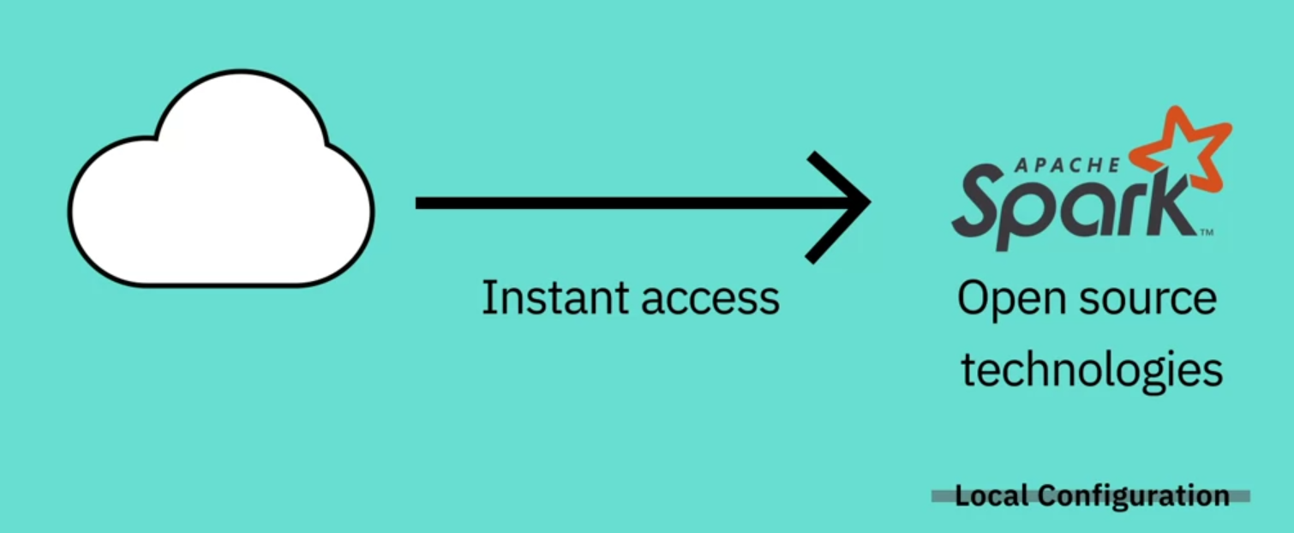

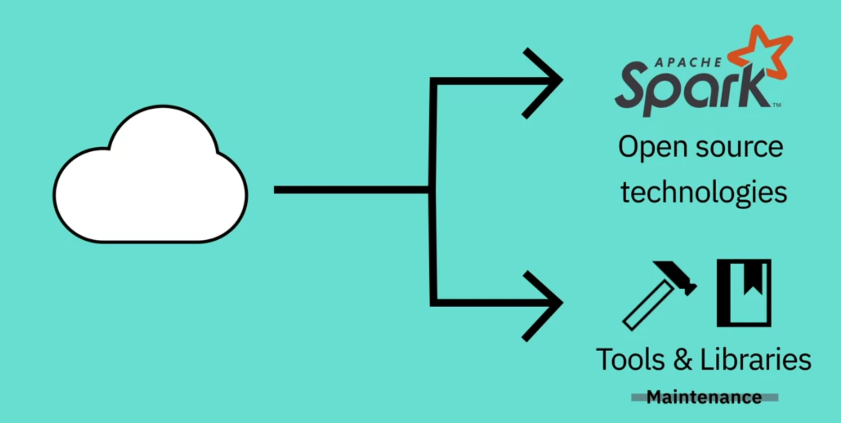

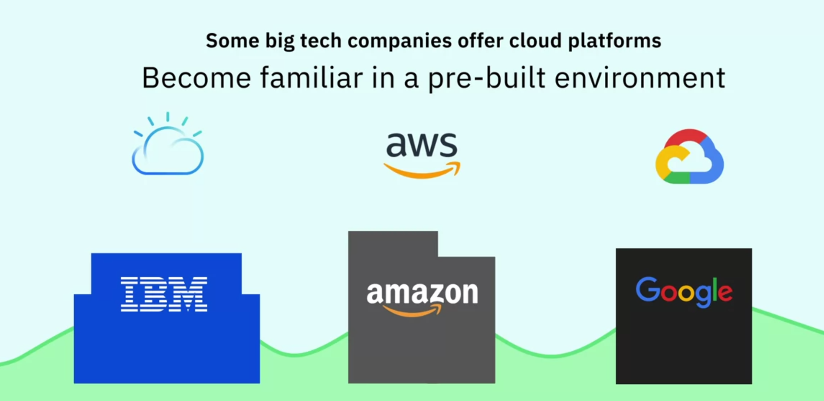

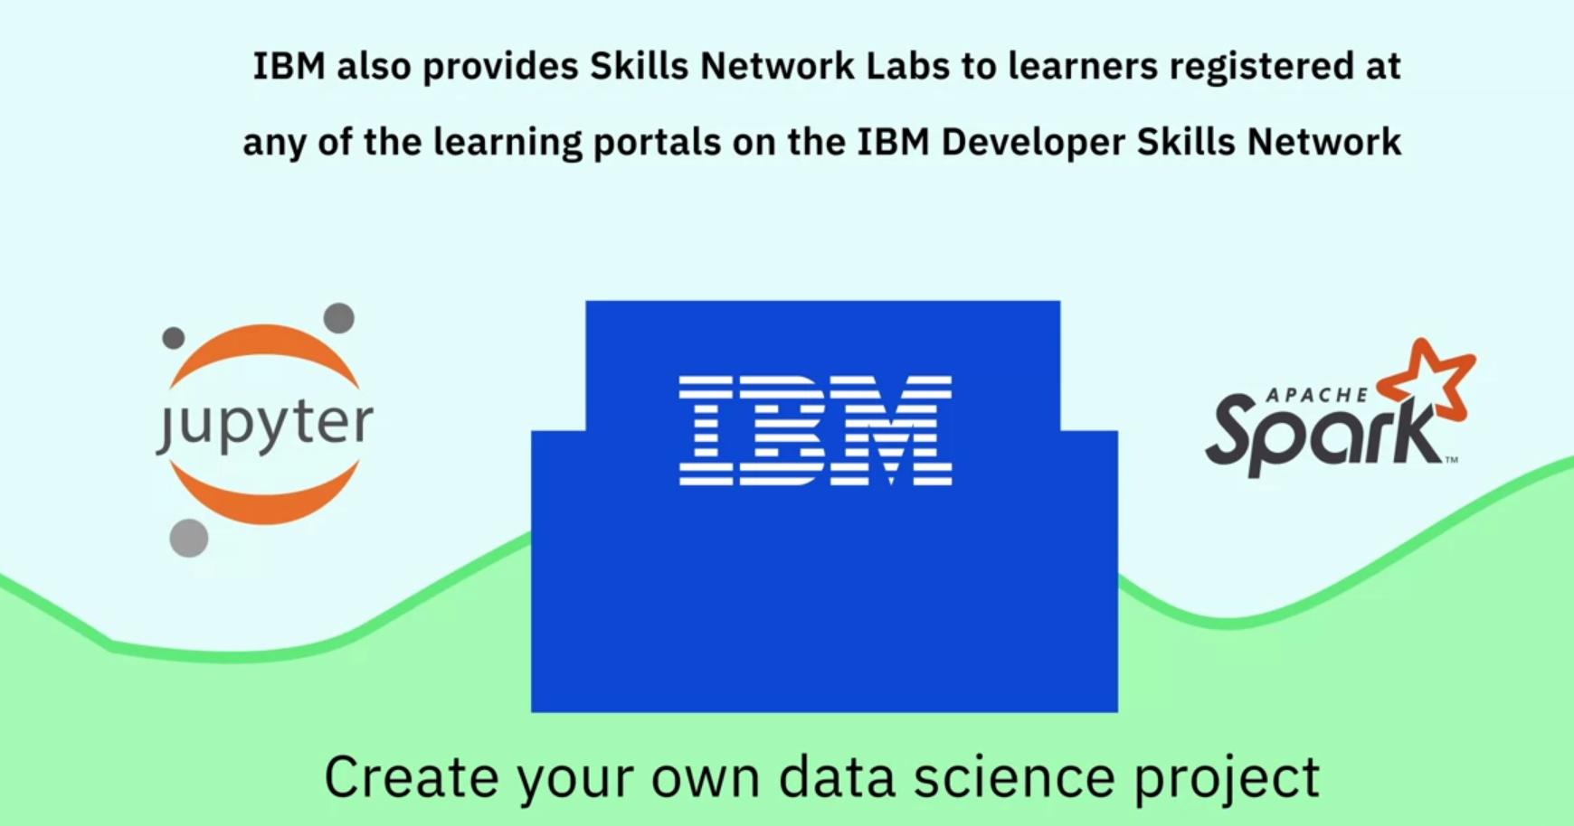

**Course Text Book: ‘Getting Started with Data Science’ Publisher: IBM Press; 1 edition (Dec 13 2015) Print.**

**Author: Murtaza Haider**

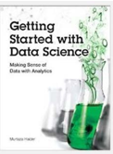

Prescribed Reading: Chapter 1 Pg. 12-15

### What Makes Someone a Data Scientist?

Now that you know what is in the book, it is time to put down some definitions. Despite their ubiquitous use, consensus evades the notions of Big data and Data Science. The question, **Who is a data scientist?** is very much alive and being contested by individuals, some of whom are merely interested in protecting their discipline or academic turfs. In this section, I attempt to address these controversies and explain Why a narrowly construed definition of either Big data or Data science will result in excluding hundreds of thousands of individuals who have recently turned to the emerging field.

**Everybody loves a data scientist,** wrote Simon Rogers (2012) in the Guardian. Mr. Rogers also traced the newfound love for number crunching to a quote by Google’s Hal Varian, who declared that ***the sexy job in the next ten years will be statisticians.***

Whereas Hal Varian named statisticians sexy, it is widely believed that what he really meant were data scientists. This raises several important questions:

* What is data science?
* How does it differ from statistics?
* What makes someone a data scientist?

In the times of big data, a question as simple as, ***What is data science?*** can result in many answers. In some cases, the diversity of opinion on these answers borders on hostility.

I define a data scientist as someone who finds solutions to problems by analyzing Big or small data using appropriate tools and then tells stories to communicate her findings to the relevant stakeholders. I do not use the data size as a restrictive clause. A data below a certain arbitrary threshold does not make one less of a data scientist. Nor is my definition of a data scientist restricted to particular analytic tools, such as machine learning. As long as one has a curious mind, fluency in analytics, and the ability to communicate the findings, I consider the person a data scientist.

I define data science as something that data scientists do. Years ago, as an engineering student at the University of Toronto, I was stuck With the question: What is engineering? I wrote my master’s thesis on forecasting housing prices and my doctoral dissertation on forecasting homebuilders’ choices related to What they build, when they build, and where they build new housing. In the civil engineering department, Others were working on designing buildings, bridges, tunnels, and worrying about the stability of slopes. My work, and that of my supervisor, was not your traditional garden-variety engineering. Obviously, I was repeatedly asked by others whether my research was indeed engineering.

When I shared these concerns with my doctoral supervisor, Professor Eric Miller, he had a laugh. Dr Miller spent a lifetime researching urban land use and transportation and had earlier earned a doctorate from MIT. “Engineering is what engineers do,” he responded. Over the next 17 years, I realized the wisdom in his statement. You first become an engineer by obtaining a degree and then registering with the local professional body that regulates the engineering profession. Now you are an engineer. You can dig tunnels; write software codes; design components of an iPhone or a supersonic jet. You are an engineer. And when you are leading the global response to a financial crisis in your role as the chief economist of the International Monetary Fund (IMF), as Dr Raghuram Rajan did, you are an engineer.

Professor Raghuram Rajan did his first degree in electrical engineering from the Indian Institute of Technology. He pursued economics in graduate studies, later became a professor at a prestigious university, and eventually landed at the IMF. He is currently serving as the 23rd Governor of the Reserve Bank of India. Could someone argue that his intellectual prowess is rooted only in his training as an economist and that the  
fundamentals he learned as an engineering student played no role in developing his problem-solving abilities?

Professor Rajan is an engineer. So are Xi Jinping, the President of the People’s Republic of China, and Alexis Tsipras, the Greek Prime Minister who is forcing the world to rethink the fundamentals of global economics. They might not be designing new circuitry, distillation equipment, or bridges, but they are helping build better societies and economies and there can be no better definition of engineering and  
engineers—that is, individuals dedicated to building better economies and societies.

So briefly, I would argue that data science is what data scientists do.

Others have many different definitions. In September 2015, a co-panelist at a meetup organized by BigDataUniversity.com in Toronto confined data science to machine learning. There you have it. If you are not using the black boxes that makeup machine learning, as per some experts in the field, you are not a data scientist. Even if you were to discover the cure to a disease threatening the lives of millions, turf-protecting  
colleagues will exclude you from the data science club.

Dr Vincent Granville (2014), an author on data science, offers certain thresholds to meet to be a data scientist. On pages 8 and 9 in Developing Analytic talent, Dr Granville describes the new data science professor as a non-tenured instructor at a non-traditional university, who publishes research results in  
online blogs, does not waste time writing grants, works from home, and earns more money than the traditional tenured professors. Suffice it to say that the thriving academic community of data scientists might disagree with Dr Granville.

Dr Granville uses restrictions on data size and methods to define what data science is. He defines a data scientist as one who can ***easily process a So-million-row data set in a couple of hours,*** and who distrusts (statistical) models. He distinguishes data science from statistics. Yet he lists algebra, calculus, and training in probability and statistics as necessary background ***to understand data science*** (page 4).

Some believe that big data is merely about crossing a certain threshold on data size or the number of observations, or is about the use of a particular tool, such as Hadoop. Such arbitrary thresholds on data size are problematic because, with innovation, even regular computers and off-the-shelf software have begun to manipulate very large data sets. Stata, a commonly used software by data scientists and statisticians, announced that one could now process between 2 billion to 24.4 billion rows using its desktop solutions. If Hadoop is the password to the big data club, Stata’s ability to process 24.4 billion rows, under certain limitations, has just gatecrashed that big data party.

It is important to realize that one who tries to set arbitrary thresholds to exclude others is likely to run into inconsistencies. The goal should be to define data science in a more exclusive, discipline- and platform-independent, size-free context where data-centric problem solving and the ability to weave strong narratives take center stage.

Given the controversy, I would rather consult others to see how they describe a data scientist. Why don’t we again consult the Chief Data Scientist of the United States? Recall Dr Patil told the Guardian newspaper in 2012 that a data scientist is that unique blend of skills that can both unlock the insights of data and tell a fantastic story via the data. What is admirable about Dr Patil’s definition is that it is inclusive of individuals of various academic backgrounds and training, and does not restrict the definition of a data scientist to a particular tool or subject it to a certain arbitrary minimum threshold of data size.

The other key ingredient for a successful data scientist is a behavioral trait: curiosity. A data scientist has to be one with a very curious mind, willing to spend significant time and effort to explore her hunches. In journalism, the editors call it having the nose for news. Not all reporters know where the news lies. Only  
those Who have the nose for news get the Story. Curiosity is equally important for data scientists as it is for journalists.

Rachel Schutt is the Chief Data Scientist at News Corp. She teaches a data science course at Columbia University. She is also the author of an excellent book, Doing Data Science. In an interview With the New York Times, Dr Schutt defined a data scientist as someone who is a part computer scientist, part software engineer, and part statistician (Miller, 2013). But that’s the definition of an average data scientist. “The best”, she contended, “tend to be really curious people, thinkers who ask good questions and are O.K. dealing with unstructured situations and trying to find structure in them.”

In this lesson, you have learned:

* The typical work day for a Data Scientist varies depending on what type of project they are working on.
* Many algorithms are used to bring out insights from data.
* Accessing algorithms, tools, and data through the Cloud enables Data Scientists to stay up-to-date and collaborate easily.

**Week 2**

**Big Data and Data Mining**

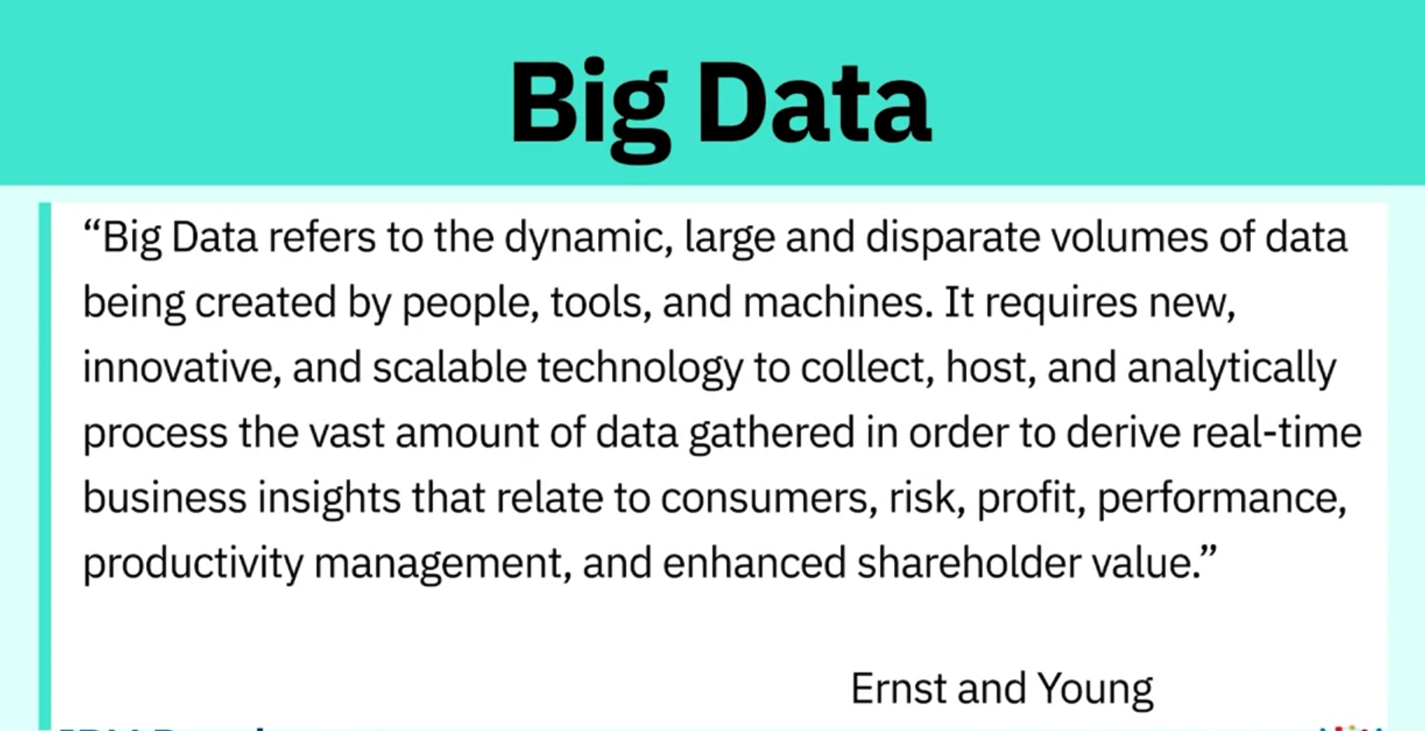

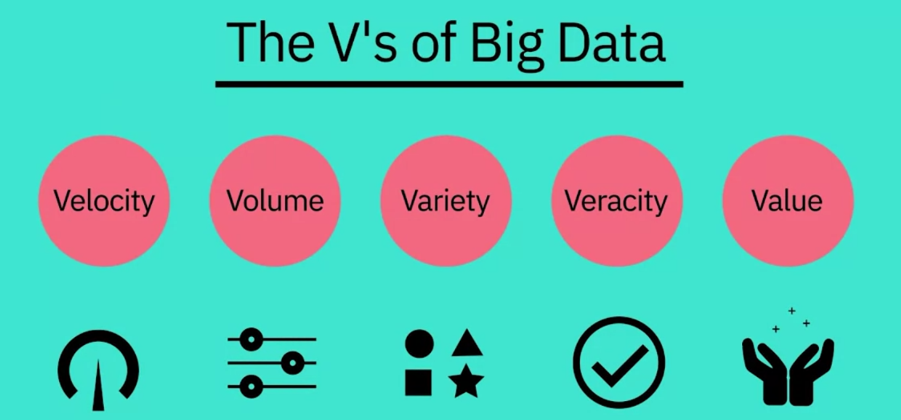

* 1. Velocity: speed at which data accumulates.
  2. Volume: scale of the data

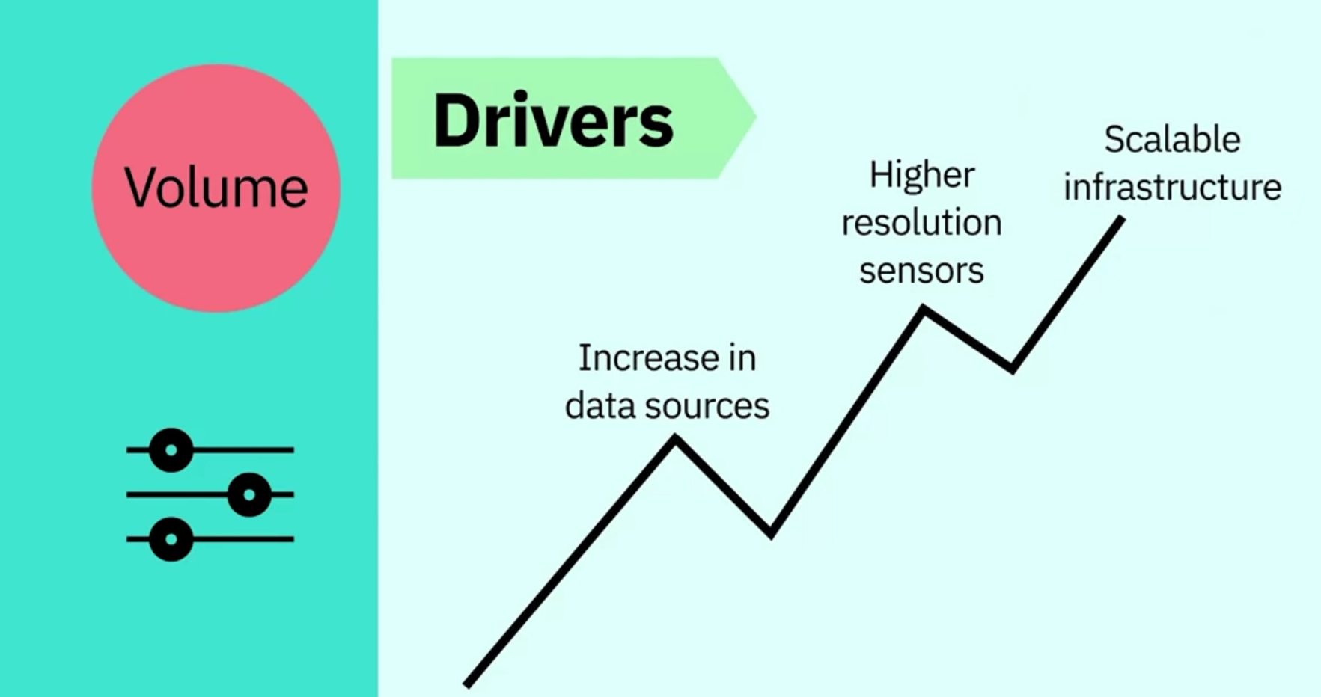

* 1. Variety: diversity of data; variety also reflects that data comes from various sources (machines, people and processes).

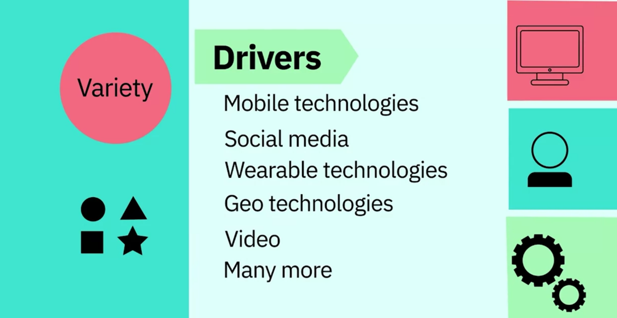

* 1. Veracity: quality and origin of data and conformity to facts and accuracy.

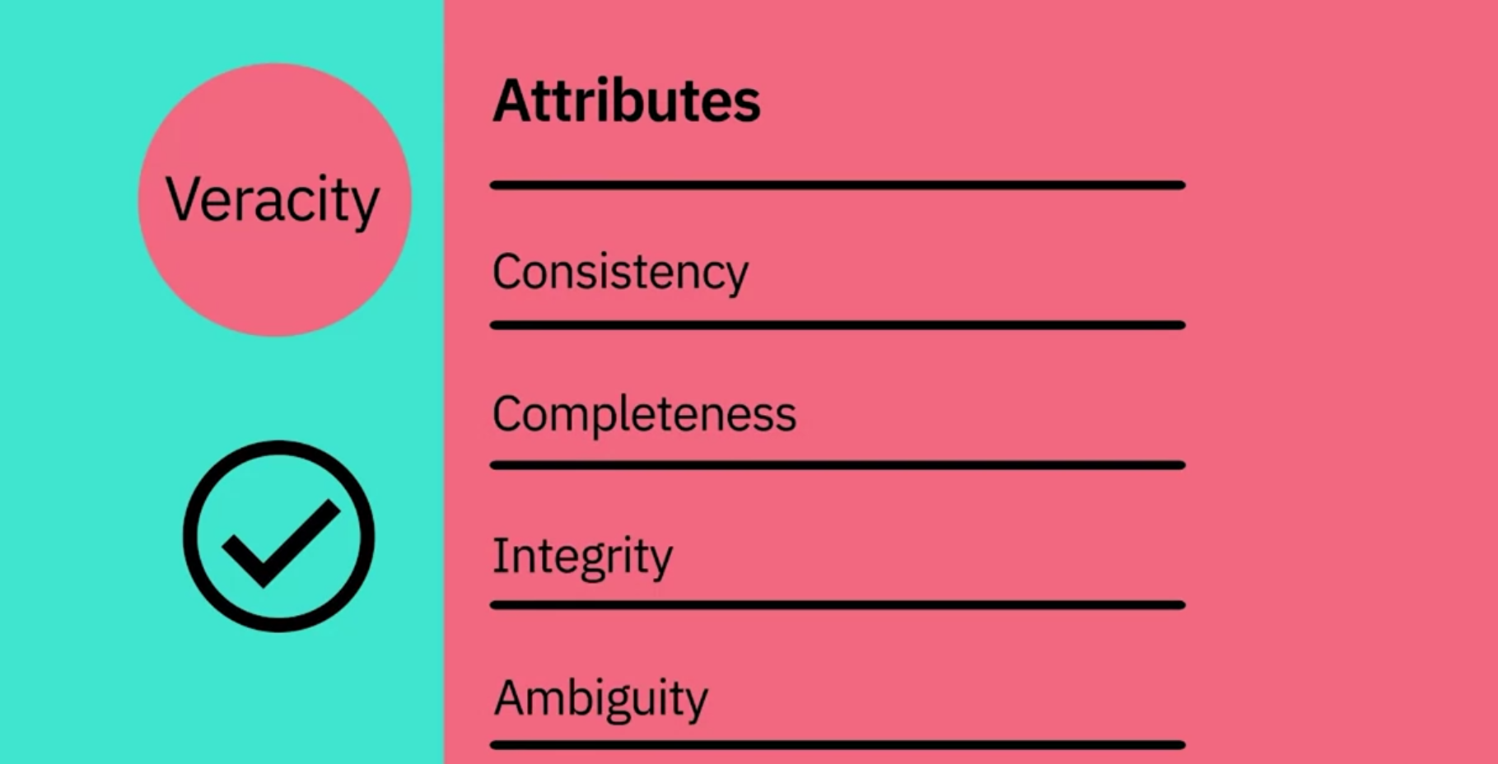

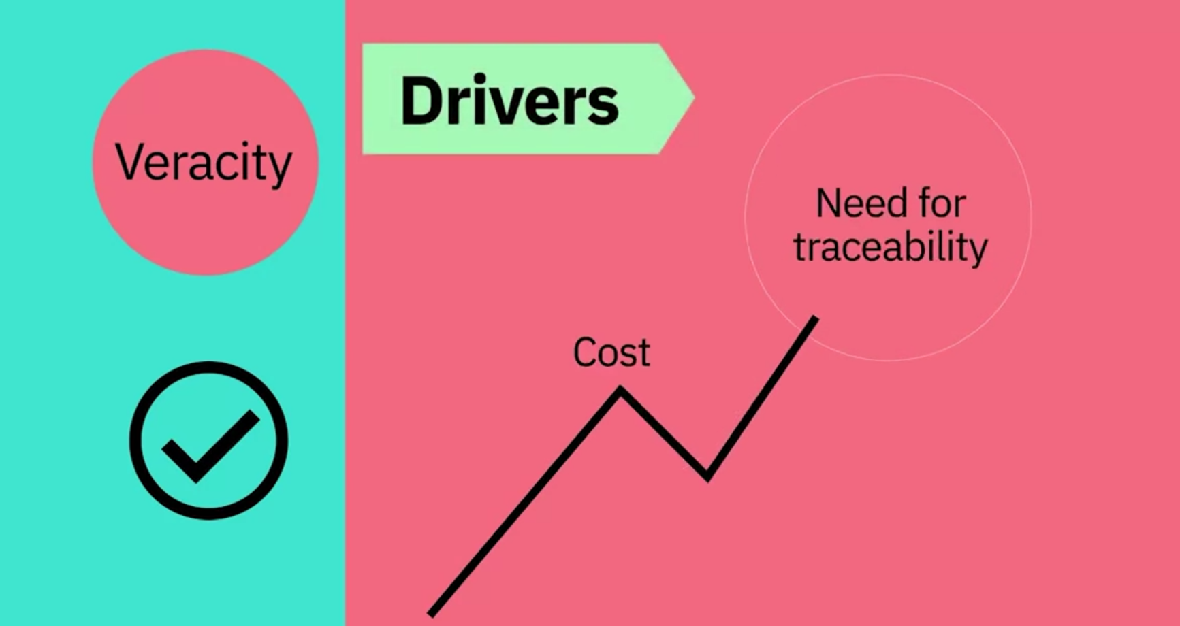

* 1. Value: our ability and need to turn data into value. The main reason that people invest time to understand Big Data is to derive value from it.

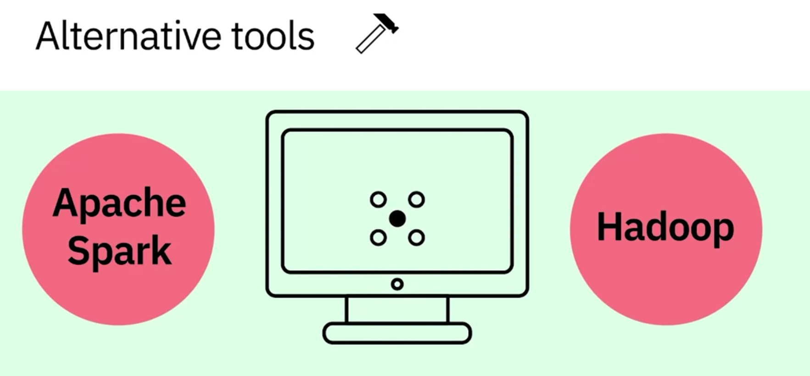

To analyze data.

According to Dr. White, most of the components of data science, such as probability, statistics, linear algebra, and programming, have been around for many decades but now we have the computational capabilities to apply combine them and come up with new techniques and learning algorithms.

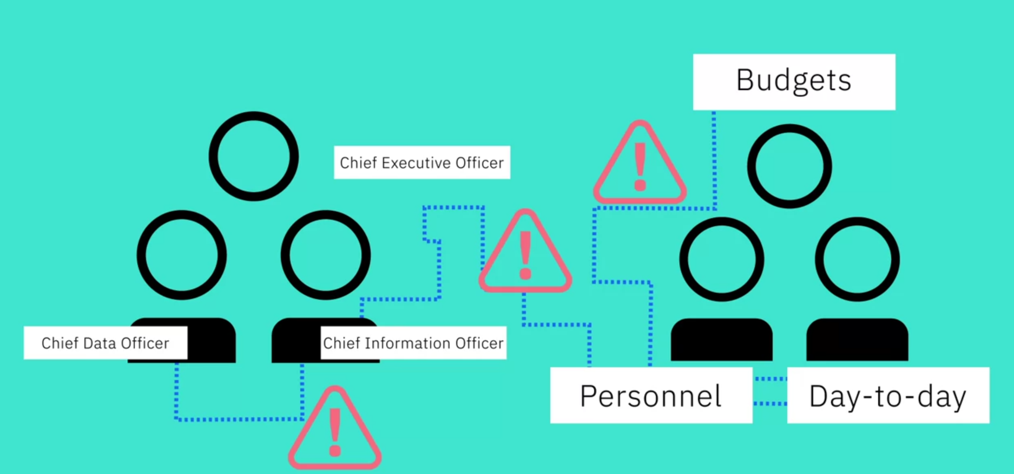

According to Dr. White, his students, who are mostly aspiring data scientists, need to learn many tools such as Python, UNIX commands, pandas, and Jupyter notebook.

Big data was started by Google when Google tried to figure out how how to solve their PageRank algorithm. Big data is data that is large enough and has enough volume and velocity that you cannot handle it with traditional data database systems.

**Course Text Book: ‘Getting Started with Data Science’ Publisher: IBM Press; 1 edition (Dec 13 2015) Print.**

**Author: Murtaza Haider**

Prescribed Reading: Chapter 12 Pg. 529-531

## Establishing Data Mining Goals

The first step in data mining requires you to set up goals for the exercise. Obviously, you must identify the key questions that need to be answered. However, going beyond identifying the key questions are the concerns about the costs and benefits of the exercise. Furthermore, you must determine, in advance, the expected level of accuracy and usefulness of the results obtained from data mining. If money were no object, you could throw as many funds as necessary to get the answers required. However, the cost-benefit trade-off is always instrumental in determining the goals and scope of the data mining exercise. The level of accuracy expected from the results also influences the costs. High levels of accuracy from data mining would cost more and vice versa. Furthermore, beyond a certain level of accuracy, you do not gain much from the exercise, given the diminishing returns. Thus, the cost-benefit trade-offs for the desired level of accuracy are important considerations for data mining goals.

## Selecting Data

The output of a data-mining exercise largely depends upon the quality of data being used. At times, data are readily available for further processing. For instance, retailers often possess large databases of customer purchases and demographics. On the other hand, data may not be readily available for data mining. In such cases, you must identify other sources of data or even plan new data collection initiatives, including surveys. The type of data, its size, and frequency of collection have a direct bearing on the cost of data mining exercise. Therefore, identifying the right kind of data needed for data mining that could answer the questions at reasonable costs is critical.

## Preprocessing Data

Preprocessing data is an important step in data mining. Often raw data are messy, containing erroneous or irrelevant data. In addition, even with relevant data, information is sometimes missing. In the preprocessing stage, you identify the irrelevant attributes of data and expunge such attributes from further consideration. At the same time, identifying the erroneous aspects of the data set and flagging them as such is necessary. For instance, human error might lead to inadvertent merging or incorrect parsing of information between columns. Data should be subject to checks to ensure integrity. Lastly, you must develop a formal method of dealing with missing data and determine whether the data are missing randomly or systematically.

If the data were missing randomly, a simple set of solutions would suffice. However, when data are missing in a systematic way, you must determine the impact of missing data on the results. For instance, a particular subset of individuals in a large data set may have refused to disclose their income. Findings relying on an individual's income as input would exclude details of those individuals whose income was not reported. This would lead to systematic biases in the analysis. Therefore, you must consider in advance if observations or variables containing missing data be excluded from the entire analysis or parts of it.

## Transforming Data

After the relevant attributes of data have been retained, the next step is to determine the appropriate format in which data must be stored. An important consideration in data mining is to reduce the number of attributes needed to explain the phenomena. This may require transforming data reduction algorithms, such as Principal Component Analysis (demonstrated and explained later in the chapter), can reduce the number of attributes without a significant loss in information. In addition, variables may need to be transformed to help explain the phenomenon being studied. For instance, an individual's income may be recorded in the data set as wage income; income from other sources, such as rental properties; support payments from the government, and the like. Aggregating income from all sources will develop a representative indicator for the individual income.

Often you need to transform variables from one type to another. It may be prudent to transform the continuous variable for income into a categorical variable where each record in the database is identified as low, medium, and high-income individual. This could help capture the non-linearities in the underlying behaviors.

## Storing Data

The transformed data must be stored in a format that makes it conducive for data mining. The data must be stored in a format that gives unrestricted and immediate read/write privileges to the data scientist. During data mining, new variables are created, which are written back to the original database, which is why the data storage scheme should facilitate efficiently reading from and writing to the database. It is also important to store data on servers or storage media that keeps the data secure and also prevents the data mining algorithm from unnecessarily searching for pieces of data scattered on different servers or storage media. Data safety and privacy should be a prime concern for storing data.

## Mining Data

After data is appropriately processed, transformed, and stored, it is subject to data mining. This step covers data analysis methods, including parametric and non-parametric methods, and machine-learning algorithms. A good starting point for data mining is data visualization. Multidimensional views of the data using the advanced graphing capabilities of data mining software are very helpful in developing a preliminary understanding of the trends hidden in the data set.

Later sections in this chapter detail data mining algorithms and methods.

## Evaluating Mining Results

After results have been extracted from data mining, you do a formal evaluation of the results. Formal evaluation could include testing the predictive capabilities of the models on observed data to see how effective and efficient the algorithms have been in reproducing data. This is known as an "in-sample forecast". In addition, the results are shared with the key stakeholders for feedback, which is then incorporated in the later iterations of data mining to improve the process.

Data mining and evaluating the results becomes an iterative process such that the analysts use better and improved algorithms to improve the quality of results generated in light of the feedback received from the key stakeholders.

Principal Component Analysis is an example of a data reduction algorithm.

After the data are appropriately processed, transformed, and stored, machine learning is a good starting point for data mining.

In-sample forecast is the process of formally evaluating the predictive capabilities of the models developed using observed data to see how effective the algorithms are in reproducing data.

* How Big Data is defined by the Vs: Velocity, Volume, Variety, Veracity, and Value.
* How Hadoop and other tools, combined with distributed computing power, are used to handle the demands of Big Data.
* What skills are required to analyse Big Data.
* About the process of Data Mining, and how it produces results.

**Deep Learning and Machine Learning**

